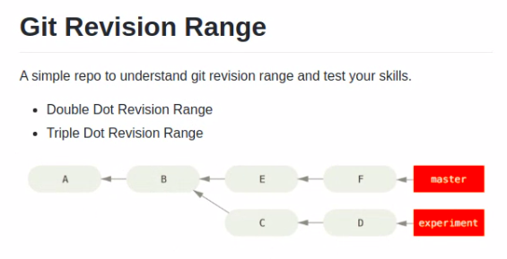
Double dot revision renges
(recommend to get check diff of two branches)
a.. f → thing that a cannot reach among f can reach
> git log

Triple dot revision ranges

things not common for both

space
(not recommend)
a c → difference comes with a

git stash

applicable when:-
quick switch branches without do commit last thing
done something in a wrong branch

store temporary in a repo
> git stash [push]

> git stash list
stash@{0}: WIP on website: e1617f5 Add basic content to index.html

> git stash apply <index>
index = stash@{0}

> git stash drop < index> - can use only after applying

can specify a massege
> git stash [push] -m “Testing”

remove and applyng
> git stash pop <index>

> git stash clear

before do stash, should add to the indexing stage

git stash show [stash index]

